Lab 3 Conditional Statement

## Instructions

1. You can edit this file online (No copy is needed)
2. For each of the answers, please fill in your answers in the designated space
3. For submission, please submit it through Talentlabs learning platform.

## Part 1 Logical Operators

### 1.1 Code Dry-running

In this section, you don’t need to write any code. Just try to run the code in your mind or on a piece of paper. DO NOT test the code with your computer.

**Please answer the questions based on this piece of code**

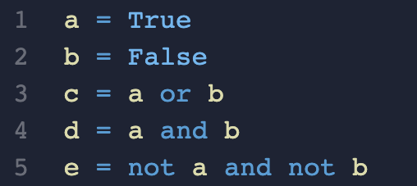

Question 1.1 What’s the output of the following statements? (Hint: the results might be more than 1 line)

Question 1.1.1

Statement: print(a and b)

|  |
| --- |
|  |

Question 1.1.2

Statement: print(b or c)

|  |
| --- |
|  |

Question 1.1.3

Statement: print(a or b or c)

|  |
| --- |
|  |

Question 1.1.4

Statement: print(a or b and c)

|  |
| --- |
|  |

Question 1.1.5

Statement: print(a or b and not c or not e)

|  |
| --- |
|  |

Question 1.1.6

Statement: print(a and not b and not (c or d))

|  |
| --- |
|  |

Question 1.1.7

Statement: print(e and b or not (a and c))

|  |
| --- |
|  |

Question 1.1.8

Statement: print(a and not b and not (a or d))

|  |
| --- |
|  |

### 

### 1.2 Code Dry-running 2 (Setting Backup Value for an Variable)

In this section, you don’t need to write any code. Just try to run the code in your mind or on a piece of paper. DO NOT test the code with your computer.

## **Please answer the questions based on this piece of code.**

Question 1.2 What’s the output of the following statements? (Hint: the results might be more than 1 line)

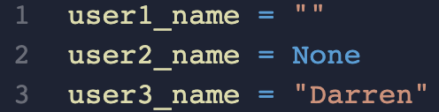

Question 1.2.1

Statement: print(user1_name or "No Name Provided")

|  |
| --- |
|  |

Question 1.2.2

Statement: print(user2_name or "No Name Provided")

|  |
| --- |
|  |

Question 1.2.3

Statement: print(user3_name or "No Name Provided")

|  |
| --- |
|  |

## 

## Part 2 Ternary Operator

### 2.1 Code Exercises

Open the lab3 folder in Visual Studio and try to finish all the exercises.

There are 5 folders in lab3 folder. For folder 1 - 4, it follows the structure below. You just need to read the exercise instruction, and finish requirements in the “Add your code here” area.

If you did not touch the “Code Setup” part, the output of your code should look like the “Expected Output”.

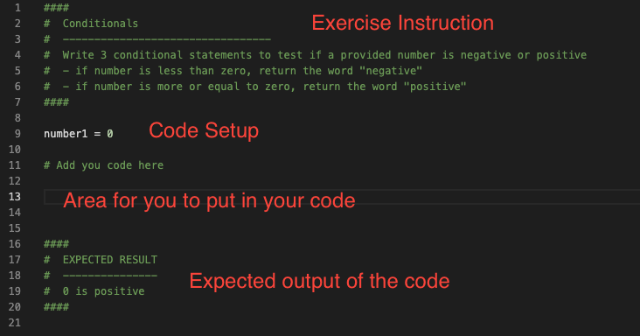

For folder 5, you are asked to finish an interactive program that asks for the user's input and react to it. Please follow the instructions in the exercise code file.